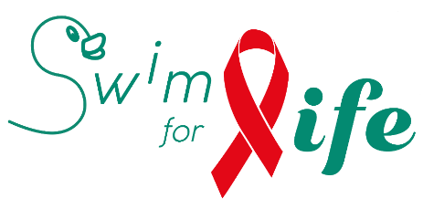

S W I M F O R L I F E 2 0 1 8
Project proposal
PLEASE DO NOT MODIFY THE TITLES IN UNDERLINE & BOLD
FILL IN THE SECTIONS AFTER EACH TITLE
YOU CAN UPLOAD UP TO 3 ANNEXES VIA THE WEB FORM
Project category

O HIV/AIDS (Belgium / Developing countries)
ou
O Discrimation LGBTQI+ (Belgium)

Short title of the project /Acronym if there is one

Name of your organisation

Legal form and date of creation

Number of persons actively involved in your organisation (permanent staff and volunteers)

Corporate goal

Address, telephone, E-mail, Website, Facebook page, Instagram account, etc

Contact person for this project: email, telephone, function

Will you conduct this project with other organisations ? (if yes, which ones)
Short description (will be used to advertise your project on our website if selected)

Type of prevention (HIV/AIDS projects only)

O Primary - focuses on preventing infections
O Secondary - addresses the effects of any contamination by medical, psychological and social support of HIV-positive people
O Tertiary - tries to stem the impact of social exclusion and discrimination so as to improve the quality of life of the infected person.

Target group(s)

Ojectives of the project

When will the project take place ?
Only projects not ended at the moment of swim for life are accepted !

Is it a one-shot or a recurrent action ?

Is this an isolated project or is it part of a broader project (in which case, describe) ?

For every activity, explain by whom it will be executed, and where and when.

What is the added value of the project for your target group?

Additional remarks

Requested financial support : EUR

!! It is very important to add a detailed budget in an annex to this request form, in which every type of expense is being detailed.– via web form !!

Have you already requested other funding for this project ?

If yes ? to which instance and for which amount?

!! Please attach your 2017 accounts– via web form !!.

Total of public funding received in 2017 by your organisation : EUR

Is your organisation able to deliver tax certificates in Belgium for donations of more than 40 €?

YES NO

Bank Communication to use for S4L Donations and IBAN/BIC

In case the project is selected, the organisation commits to:

- Ensure that at least one person of the association / organisation will
be present at the occasion of the official presentation of the results (in
the spring of 2019);

- Deliver the necessary information to promote the project to the
participants and the sponsors of the Swim For Life "swim-a-thon";

- Promote actively events around Swim for life on its website and social
media;

- Deliver, in accordance with a schedule to define, a progress report
on the project, and at the end of the project, a final report;

- Mention the support of Swim For Life in every publication (printed or
web) that is related to the present project: “With the support of Swim
For Life 2018”

